Design and modification of processing schemes for three kinds of parts in a new-type ski

by

Longfu Hu

A Thesis

Presented to the Graduate and Research Committee

of Lehigh University

in Candidacy for the Degree of

Master of Science

in

Mechanical Engineering

Lehigh University

05. 2017

© Copyright by Longfu Hu 2017

All Rights Reserved

Certificate of approval

This thesis is accepted and approved in partial fulfillment of the requirements for the Master of Science.

_______________________

Date

______________________

Thesis Advisor

______________________

Co-Advisor

______________________

Chairperson of Department

Acknowledgements

I would first like to thank my thesis advisor Professor Joachim L Grenestedt of P.C. Rossin College of Engineering and Applied Science. The door to his office was always open whenever I ran into a trouble spot or had a question about my research or writing.

I would also like to thank the engineers who were involved in the manufacturing work for this project: William J. Maroun and Eli C. Towne. Without their passionate participation and input, the machining work could not have been successfully conducted.

Contents

Abstract 5

Part 1: Ss02rafA 8

1.2 Determine the blank 9

1.3 Determine main processing route 9

1.4 Test and modification 10

1.5 Datum reference and clamping 13

1.6 Determine machining procedure card 15

1.7 Future work 15

Part 2: Ski susp 02 rocker arm rear A 16

2.2 Determine the blank 17

2.3 Determine main processing route 18

2.4 Test and modification 18

2.5 Datum reference and clamping 19

2.6 Determine machining procedure card 22

Part 3: Ski susp 02 bracket lower front A 23

3.2 Determine the blank 23

3.3 Determine main processing route 24

3.4 Test and modification 25

3.5 Datum reference and clamping 28

3.6 Determine machining procedure card 30

3.7 Future work 30

Refences 32

Appendix A: Machining procedure card of “Ss02rafA” 33

Appendix B: Machining procedure card of “Ski susp 02 rocker arm rear A” 34

Appendix C: Machining procedure card of “Ski susp 02 bracket lower front A” 35

Vita 36

Lists of drawings

Drawing 1.1 Three-view drawing of model “Ss02rafA” 8

Drawing 1.2 Four positions for multiple steps of processing 8

Drawing 1.3 Locations and diameters of two location holes 14

Drawing 2.1 Three-view drawing of model “Ski susp 02 rocker arm rear A” 16

Drawing 2.2 Four positions for multiple steps of processing 16

Drawing 2.3 Place two blanks in one block 17

Drawing 2.4 Locations and diameters of two groups of location holes 20

Drawing 2.5 Location diagram when part is located on the plate 20

Drawing 3.1 Three-view drawing of model “Ski susp 02 bracket lower front A” 23

Drawing 3.1 Location of the origin 29

Lists of illustrations

Illustration 1.1 Tool marks caused by multiple-level cutting 10

Illustration 1.2 Contrast of processed surface 11

Illustration 1.2 Contrast of processed bottom 12

Illustration 2.1 Different combination of supports for different processing position 21

Illustration 3.1 Blank with location holes 24

Illustration 3.2 Contrast of processing effect on slope 26

Illustration 3.3 Contrast of blending 28

Illustration 3.4 Grab part of the blank to make room for processing slots 29

Illustration 3.5 Use 82-degree screws to fix blank on the plate 30

# Abstract

Nowadays CAD/CAM/CNC have been widely applied to all fields of manufacturing and production. With the help of them, ideas and designs can be brought to reality. The author has joined a project of designing skis with new structural concepts and is primarily responsible for manufacturing parts. This thesis states the whole design procedures of manufacturing three kinds of complex parts. Starting with analyzing models, for different parts, multiple relevant processing plans are designed and G codes are generated with the help of CAM software. By practically metalworking and operating CNC machines, original plans are improved, even overturned until appropriate machining routes including accurate fixture solutions are achieved, which play a referential role in mass production in the future.

# Part 1: Ss02rafA

* 1. Structural analysis

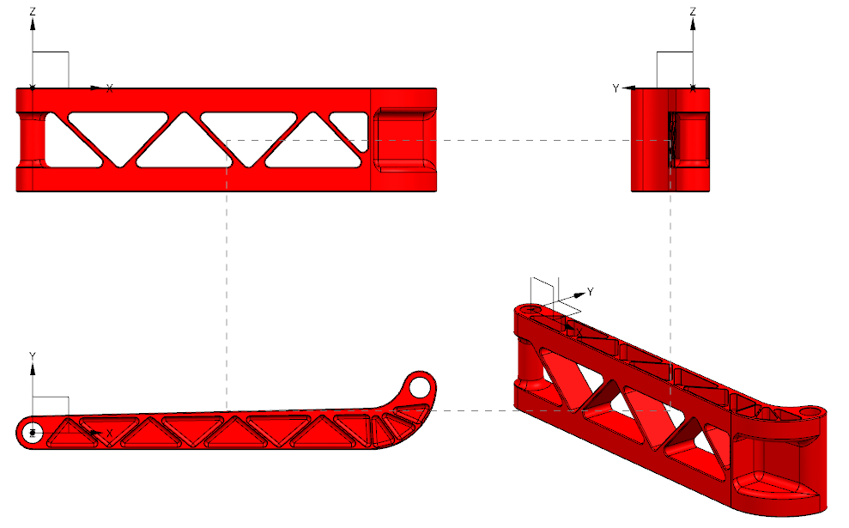

##### Drawing 1.1 Three-view drawing of model “Ss02rafA”

The CNC for machining, HAAS DT-1, is a vertical machining center with three degree-of-freedom, which means that for such 3D part, at one time only part of its surface can be machined. According to the shape of this part, it can be divided into four positions, which are named as “top”, “bottom”, “side 1” and “side 2”.

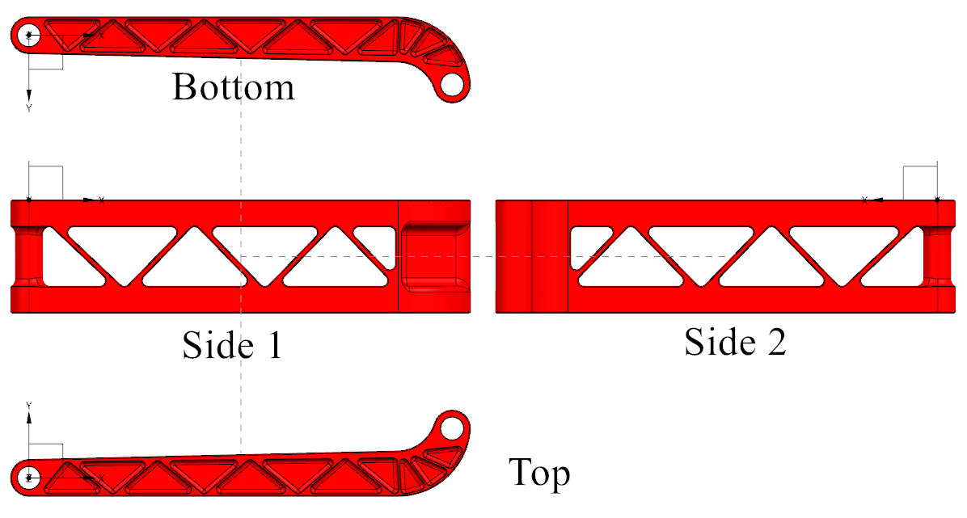

Drawing 1.2 Four positions for multiple steps of processing (note that their names are

different from them of views)

Most areas on this part are planes and vertical walls, so to use end mills would be the priority selection.

## Determine the blank

As required, the material for making this part should be Aluminum 7075 (for the first time of CNC operation I chose Aluminum 6061 for testing). A cuboid block with the size of 165mm (6.5 inches) ×38mm (1.5 inches) ×40mm (1.6 inches) is appropriate. The length and width is 0.1~0.2 inches longer that the exact size of the part, which can leave enough allowance for milling the profile, and the height is just the exact size since the top and bottom surfaces are flat and no more processing is needed after finish-milling.

## Determine main processing route

The very first processing work should be that drill holes in the location of Φ8mm holes. Relative positions of centers of Φ8mm holes need to be measured from CAD model. Diameters of holes should be smaller than the required size. The allowance will be cut off in the final operation.

Preparation: drill two holes (spot drill and #3 drill)

“Top”: cut and finish profile (3/4-inch end mill) → mill triangle holes on top surface (1/4-inch end mill and 1/8-inch ball mill) → chamfer top surface (3/8-inch drill)

“Bottom”: mill triangle holes on bottom surface (1/4-inch end mill and 1/8-inch ball mill) → chamfer bottom surface (3/8-inch drill)

“Side 1”: mill triangle through-holes on side 1 and chamfer (1/4-inch end mill and 1/8-inch ball mill and 3/8-inch drill) → mill top half cylinder (1/4-inch end mill and 1/8-inch ball mill) → mill arc slot (1/4-inch end mill and 1/8-inch ball mill)

“Side 2”: mill bottom half cylinder (1/4-inch end mill and 1/8-inch ball mill) → chamfer the other side of triangle through-holes (3/8-inch drill)

## Test and modification

During operating CNC to test the preliminary processing plan, a variety of problems have occurred and it was necessary to modify the plan:

1. For the step “cut and finish profile”, when operating CNC for the first time, the profile of the part was not flat and smooth. Many levels of parallel lines could be seen along the part. The 3/4-inch end mill cut the whole profile level by level, as a result, between two levels blending could not be definitely smooth, which can be seen from photos below:

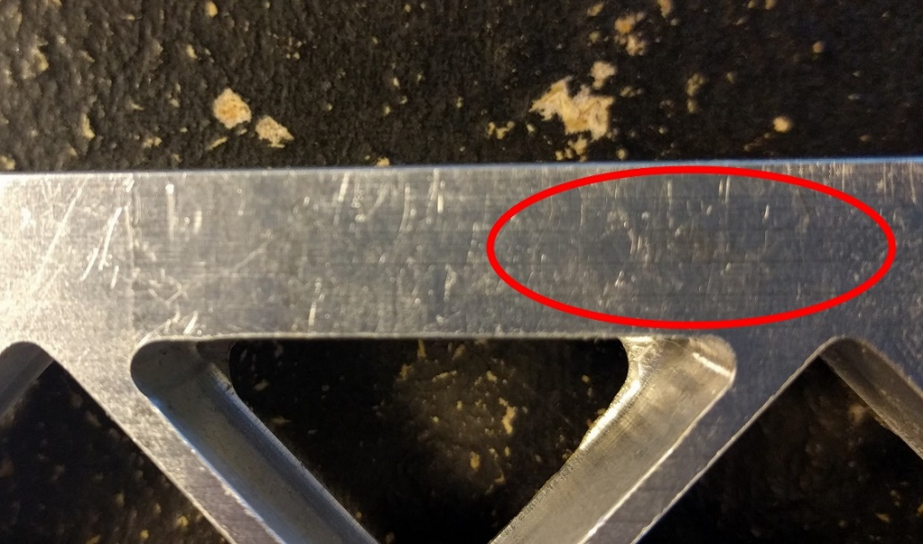

###### Illustration 1.1 Tool marks caused by multiple-level cutting

The conflict is, when cutting the block, it is impossible for milling cutter move for only one loop to get a smooth surface, so it is necessary to let it cut material off by multiple levels to avoid being broken or breaking the block. After that, there will be no allowance for finishing. To solve this problem, a “tricky” method was adopted. When setting parameters in UG NX, I changed the diameter of end mill from 3/4 inches to 0.770 inches and generated G-code. However, I still used 3/4-inch end mill to mill the profile, so there would be allowance left after 3/4-inch end mill cut off most material. Then I let the same cutter run again with the blade covering the whole profile (from top to bottom) to cut the rest material. As a result, the profile could be flat and smooth.

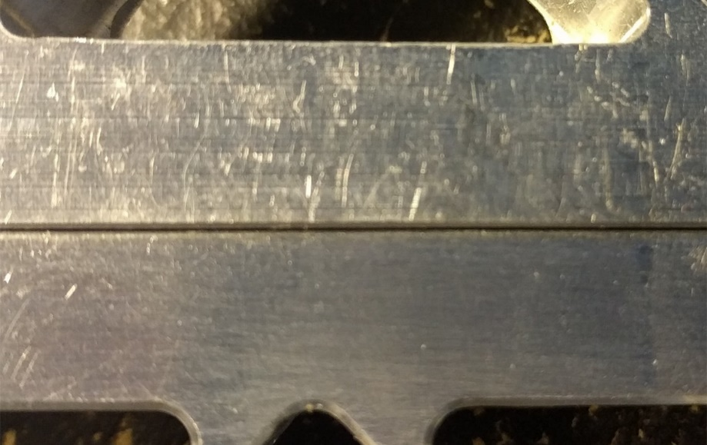

Illustration 1.2 Contrast of processed surface (Upside: “tricky” method not applied;

downside: “tricky” method applied)

1. There were triangle tool marks on the bottom of the triangle slots, which was resulted from using 1/8-inch ball mill to finish the bottom. To avoid this situation, I divided the bottom of slots into two area: let 1/8-inch ball mill just fillet the edge of the bottom and add an operation which is using 1/8-inch end mill to finish walls and floors of slots. For end mill and ball mill with the same diameter, the former is stronger than the latter, so in the following process, end mills should be used more often for cutting off most material and ball mills are only chosen for final steps such as filleting or contour area milling. This will be not only efficient but also reduce the risk of breaking tools.

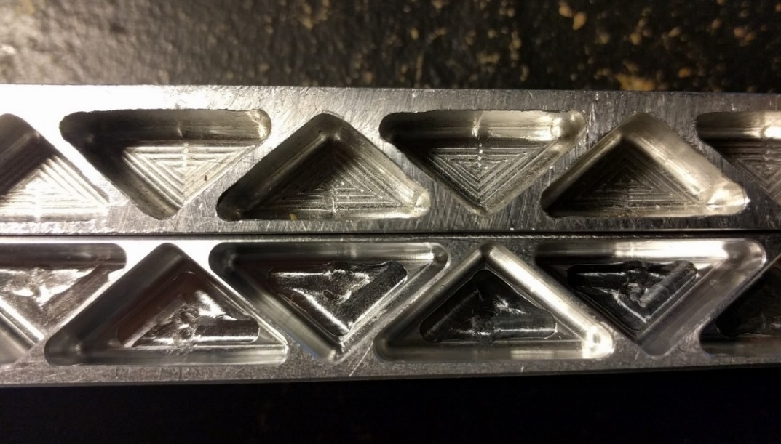

Illustration 1.2 Contrast of processed bottom (Upside: milled with ball mill;

downside: milled with end mill)

1. Around the edge of bottom of through-holes, there was remaining material. One possible cause is that the range of cutting level was not set appropriately in UG NX. If the cutting range is defined automatically, it is frequent that the last loop cannot cut off all the material in the through-holes. Therefore, it is recommended that this range should be defined by customers to ensure border-bottom to be lower than the bottom of through-holes. The other possible cause is that in order to reduce times of changing tools I only use ball mills for finishing. Because of the shape of tool nose, material along the edge would be difficultly cut off. Instead, an end mill can solve this problem.
2. There were small steps on the arc slot. To solve it, I have tried to use smaller ball mill and reduce the stopovers, which can achieve better results but at the same time take more time. Actually, considering the shape of the bottom of this slot, it is inappropriate to choose cavity mill. Instead, for machining such kind of curve area, contour area mill could be more useful, which can mill smooth surfaces without taking more time. However, to adopt this operation has a certain requirement. I have not tried this operation on this part but on the other parts. Further discussion and analysis will be stated later in this thesis. In last step, 8-mm holes were drilled by vertical driller which caused threads on the inner walls. To use a reamer could solve this problem well but there was no 8-mm reamer in workshop so I did not choose this operation when machining the first two part. This operation could be improved more in the future

## Datum reference and clamping

Since it takes four steps to machine all the part, multiple reference and clamping methods should be chosen for each step.

Preparation: the block can be grabbed with vise and located by parallel bars. When one center of holes is determined, the other one is determined too.

Top: choose centers of two Φ8mm circles for location, left center as origin, bottom surface as reference; In the first step, the profile of the part should be machined, so the blank should not be directly grabbed on the vise. Instead, a plate is needed for locating and clamping.

1. Select an appropriate plate, finish all six surfaces to 8.0 inches (203.2 mm) ×5.0 inches (127.0 mm) ×0.75 inches (19.1 mm)
2. Find coordinates of two centers, locate on the plate, drill holes with #3 drill and tap

Note: drill through-hole for utilizing both sides of the plate

1. When machining, use 1/4-20 screws to fix

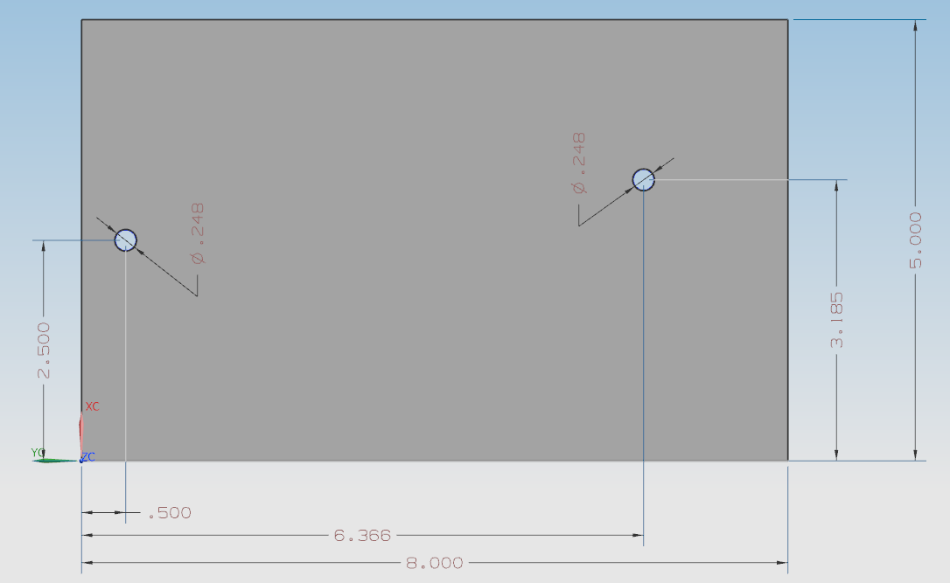

##### Drawing 1.3 Locations and diameters of two location holes

Bottom: choose centers of two Φ8mm circles for location, left center as origin, top surface as reference;

Note: after first step, the block and the plate should be turned upside down and the block could be located and fixed by the same two holes, which can reduce errors from multiple location and working procedure.

Note that side 1 and side 2 are not parallel and triangle through holes are perpendicular to side 1 surface, so they should be finished when the blank is in “side 1” position.

Side 1: choose left center as origin, side 1 surface as reference;

Side 2: choose left center as origin, side 1 surface as reference.

For machining “side 1” and “side 2”, the blank can be directly grabbed by the vise, being positioned by parallel bars.

## Determine machining procedure card

Complete machining procedure card has been made and, due to space limitations, showed as an appendix in the last part of this thesis. Please refer to *Appendix A: Machining procedure card of “Ss02rafA”* on Page 33.

## Future work

Due to time constraints and lack of experience, when reviewing the whole process after finishing two required parts, I find there are still many improvements worth attempting:

1. By properly placed, two blanks can be cut from one block instead, which can save much material in comparison to that one part was cut from one block while a lot of swarf appears.
2. Contour area milling was not applied when processing the first part. The curve surfaces on the part can still be processed better.
3. Lack of tools led to that holes were not that accurate. A reamer is always a better choice to get better inner walls.

Fortunately, in the following work, I had chances to try and achieve significant results.

# Part 2: Ski susp 02 rocker arm rear A

* 1. Structural analysis

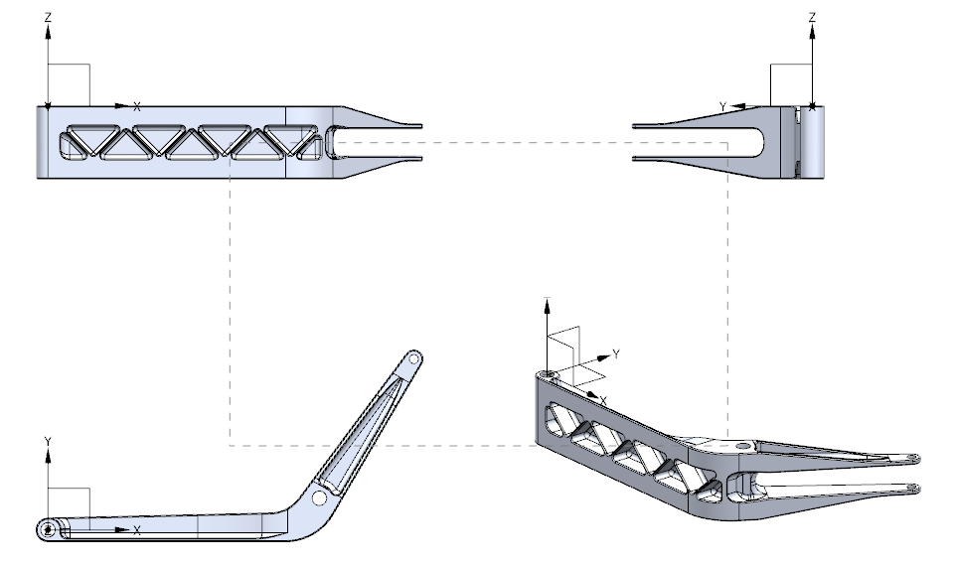

##### Drawing 2.1 Three-view drawing of model “Ski susp 02 rocker arm rear A”

Generally, this part is similar to the first one, so it is still necessary and reasonable to divide the whole machining work into four positions, which can be also named as “top”, “bottom”, “side 1” and “side 2”. Note that compared with the first part, the flection on this one extends more that makes the profile looks like a distorted “L”.

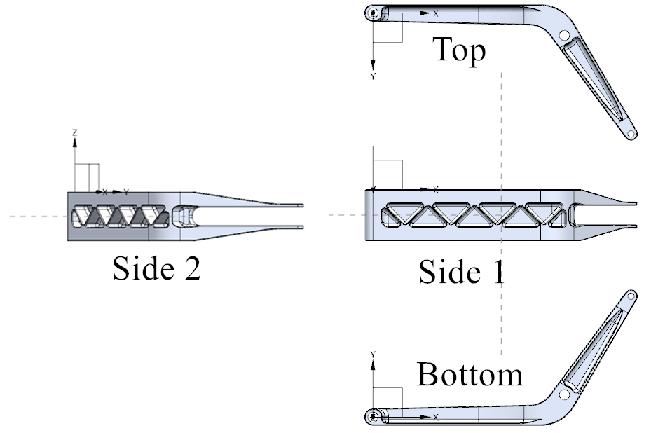

##### Drawing 2.2 Four positions for multiple steps of processing

From the top (or bottom) view in the drawing 2.2, the height is 4.15 inches (105.45mm), which means when processing one side from the inside of “L”, the other side is easy to interfere tools. Additionally, there are not many areas need to machine inside of “L”, so positon “side 1” and “side 2” should be determined to let the tool cut from outside of the part. There are many curved surfaces and smooth blending on this part. Compared to machining methods of the first part, more ball mills and contour area milling should be chosen.

### Determine the blank

Considering the profile of this part, “L” shape would waste a lot of material if each part is machined from one square block. Therefore, this time I decided to cut the blank for two parts from one block. These two blanks have the same profile as the part with the offset of 0.1 inches. How they were positioned can be seen from the drawing below:

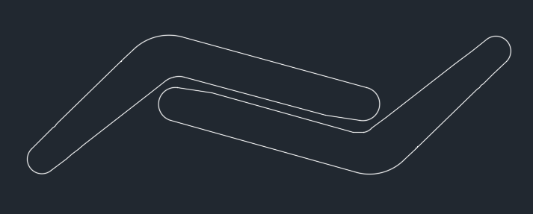

##### Drawing 2.3 Place two blanks in one block

The order of cutting is very important. If we just position profiles of two parts in a square optionally, it is almost impossible to locate three centers of circles on the blank. It is essential to locate and drill the three holes (totally six holes for two blanks) firstly, then cut the blanks with waterjet.

There is another important preparation work before main machining work. One side of the part is like a “U” fork but the slot cannot be cut in one time because a bolt for fixing will be through the top of the fork and interfere tools. This area should be machined beforehand to reserve space for the bolt.

### Determine main processing route

“Top”: cut and finish profile (3/4-inch end mill) → mill long slots on top surface (3/8-inch end mill) → finish top surface using contour area milling (3/16-inch ball mill)

“Bottom”: mill long slots on bottom surface (3/8-inch end mill) → finish bottom surface using contour area milling (3/16-inch ball mill)

“Side 1”: roughly mill triangle holes on “side 1” surface (1/4-inch end mill and 1/8-inch end mill) → finish triangle holes and chamfer (1/8-inch ball mill)

“Side 2”: cut the rest area of “U” fork and roughly mill irregular slot (1/2-inch end mill) → finish irregular slot using contour area mill (1/8-inch ball mill)

### Test and modification

When testing this route in CNC, there are no obvious problems. Two steps need to be pay attention to:

1. In the first operation, the technique applied on the first part should be used again to get smoother profile.
2. If 1/8-inch ball mill follow the 1/2-inch end mill in the last operation, although good effect can be achieved. The risk of tool damage still probably occurs and the time is too long. Therefore, I added one operation “finish irregular slot with 1/4-inch ball mill” between these two operations. The risk is reduced while the time is shortened from 11 minutes to 5 minutes.

### Datum reference and clamping

The aforementioned preparation work should be done before screws are used to fix the blank, so that is the only operation in which the blank need to be grabbed by vise.

Preparation: grabbed with vise and located by parallel bars, choose “side 1” surface as reference, manually write G code to mill the top end of “U” fork.

Since the height of this part is more than that of vise, for all the four positions, vise cannot be used to grab the blank. Instead, a plate should be introduced for clamping. The three centers of holes on the part could be used for location and with screws the blank could be fixed on the plate, so what is actually grabbed in the vise is the plate. This is my main thinking for clamping. Drilling three through-holes in the plate is enough for fixing the blank and machining “top”, “bottom” and “side 1 (or side 2)”, but the last two operations cannot be processed in the same position. The reason is that the angle between two legs of “L” is not 90 degrees. Since the plate is square, when the part is placed on the plate with one of its leg parallel with one side of the plate, the other leg should not be parallel with the adjacent side. The drawing below shows my plan of fixing. In this plate, I drilled two groups of through-holes. Each group has three through-holes corresponding to three holes in the part. One group is used for “top” and “side 1”, the other one is for “bottom” and “side 2”.

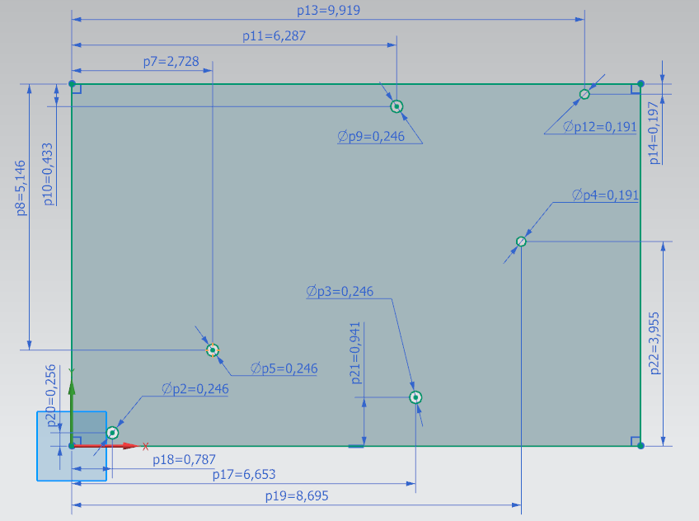

##### Drawing 2.4 Locations and diameters of two groups of location holes

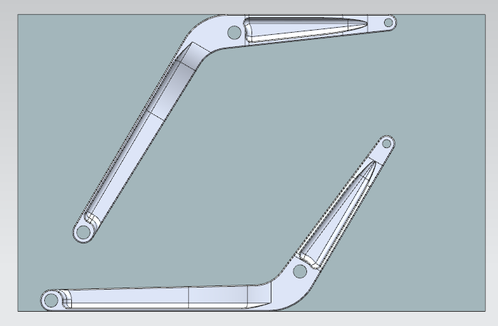

##### Drawing 2.5 Location diagram when part is located on the plate

For holding the suspend fork, three supports were lathed by hand, which are shown below. The shorter one is applied between the plate and the part. The other longer two are for holding the slot. One of them has been tapped inside. These small cylinders, combined with a bolt and a nut, can meet the requirement of fixing for all the four positions. The left picture shows how to support suspended fork when processing top or bottom surface. The shorter one supports the lower leg and the longer one supports the higher leg. Here the longer one should be the one with thread to tighten the bolt. Note that the bolt should not stick out of the upper surface otherwise it will interfere tools. The right picture shows how to support suspended forks when processing “side 1” and “side 2”. Especially, when tools are processing the “side 2”, they engage in the direction perpendicular to the bolt. Both legs need to be supported. The bolt has to go through the long support in the middle (now it is the one without threads), stick out and be tightened by the tapped long support.

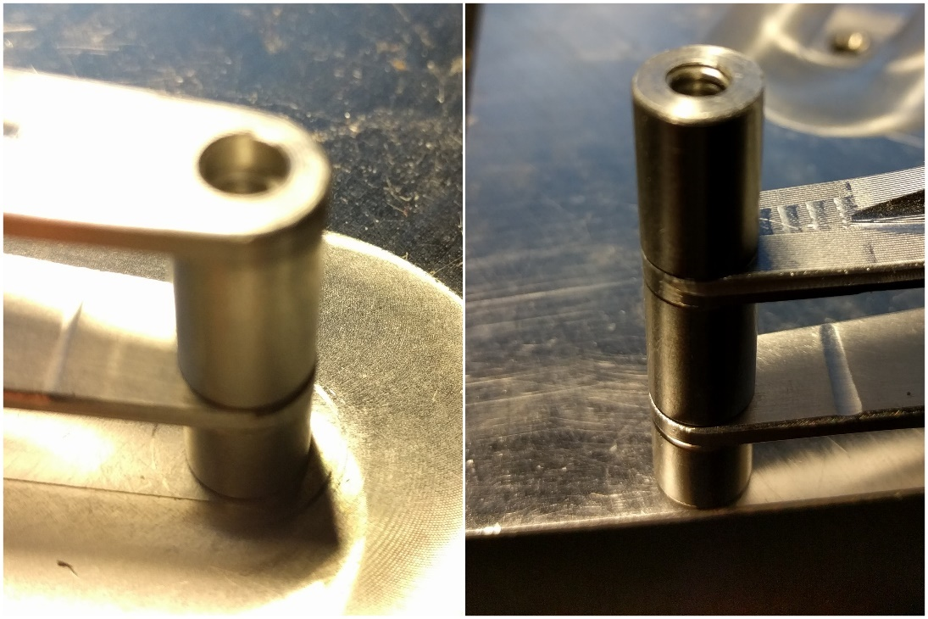

###### Illustration 2.1 Different combination of supports for different processing position

Top: choose centers of two Φ8mm circles for location, left center as origin, bottom surface as reference;

Bottom: choose centers of two Φ8mm circles for location, left center as origin, top surface as reference;

Side 1: choose centers of two Φ8mm circles for location, left center as origin, top surface as reference;

Side 2: choose centers of two Φ8mm circles for location, right center as origin, bottom surface as reference;

### Determine machining procedure card

Complete machining procedure card has been made and, due to space limitations, showed as an appendix in the last part of this thesis. Please refer to *Appendix B: Machining procedure card of “Ski susp 02 rocker arm rear A”* on page 34.

# Part 3: Ski susp 02 bracket lower front A

* 1. Structural analysis

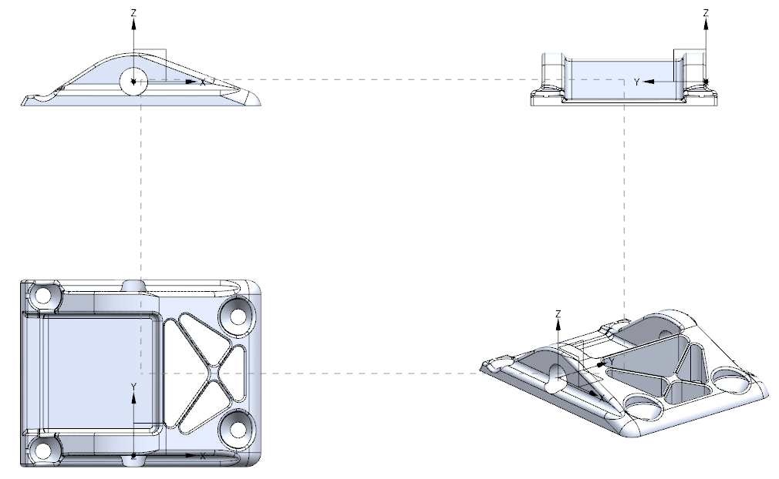

##### Drawing 3.1 Three-view drawing of model “Ski susp 02 bracket lower front A”

This part is different from the first two parts. On the one hand, almost all the areas that need to be machined are on top of part, which means there is no need to move or turn the blank when machining. But on the other hand, there is no vertical wall around the part. It is impossible to grab the blank directly with the vise when processing four sides and the four slots and holes distributed on the part should be used for fixing. The profile and shape are more complicated than the first two parts. The whole machining process will be a collection of cavity milling, contour area milling and planar milling. End mills should be chosen for cutting off material in the center and ball mills would be used more often when machining four corners of this part.

#### Determine the blank

The blank was cut by water jet and finished to 3.346 inches (85 mm) ×2.598 inches (66 mm) ×1.000 inch (25.4 mm) at the very start. The length and the width are exactly the same as them of model. However, the height turned out to be not appropriate in the following machining work. Most Lengths of cut of tools in the workshop were 3/4 inches. When cutting deeper they (or collets) were easy to hit the blank and break. Even though longer tools which have 1-inch lengths of cut were ordered later, I determined to mill the blank further until the height was no more than 3/4 inches to ensure there is enough clearance for safety. Then the traverse hole should be drilled by w drill and reamed by 10-mm reamer because this operation is in a position different from all the other operations. At last, four holes distributed on the part could be drilled by #11 drill. The diameter of #11 drill is 0.191 inches (4.85 mm) which is smaller than the exact size because this preprocessing is for location and the holes will be machined to the exact size in the following work.

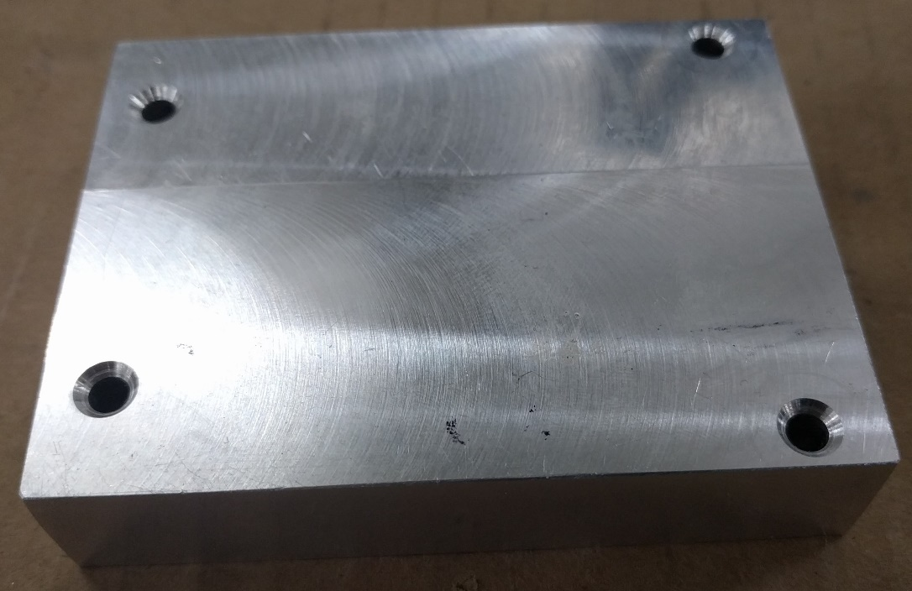

###### Illustration 3.1 Blank with location holes

#### Determine main processing route

Generally, the whole process has two part: four corners and central part. Considering that if the four corners are processed before central part, tools especially 1/8-inch mills which are of lower strength may probably hit high walls in the center and be broken, I chose to process the central part firstly then four corners.

Roughly mill the central part (1/4-inch end mill and 1/8-inch end mill) → finish the central part using contour area milling (1/8-inch ball mill) → Roughly mill four slots and holes (1/4-inch end mill and 1/8-inch end mill) → finish four slots and holes using contour area milling (1/8-inch ball mill)

Note that when processing the central part the blank should be fixed by socket screws and each of them need to be removed when processing each slot and replaced with 82-degree screws which has the same diameter.

#### Test and modification

After following the route above to process the blank in CNC, some problems appeared:

1. If the 1/8-inch ball mill is used to finish the surface following 1/8-inch end mill, loud noise will be made and more seriously, ball mills are easy to break off. The cause is that after being roughly milled by end mills, steps on the blank are too high for 1/8-inch ball mills to finish. In addition, getting smoother surfaces means that smaller step-overs and feed rates have to be set. Using 1/8-inch ball mill to finish all surfaces will take hours, which is very inefficient. So, I added an operation “contour area milling with 1/4-inch ball mill” before that operation. To finish most areas only takes about 20 minutes. And it can create better machining environment for the following operation. Next, 1/8-inch ball mill only has to process corners where 1/4-inch ball mill cannot reach.
2. End mills are set to process part with the cutting pattern “follow part”, so when milling the slope, they will leave such tool marks like steps parallel to the short side. In the following operation if ball mills are set to cut as “follow periphery”, tools will move along the similar tracks with smaller step-overs. As a result, toolpaths of end mills and ball mills will have overlaps and some steps left by end mills cannot be finished by ball mills, which can be seen from the left of pictures below; To mitigate this condition, I reset the cutting pattern of ball mills as “zig-zag”, which can let tools follow such paths perpendicular to previous paths and clear away most remained material.

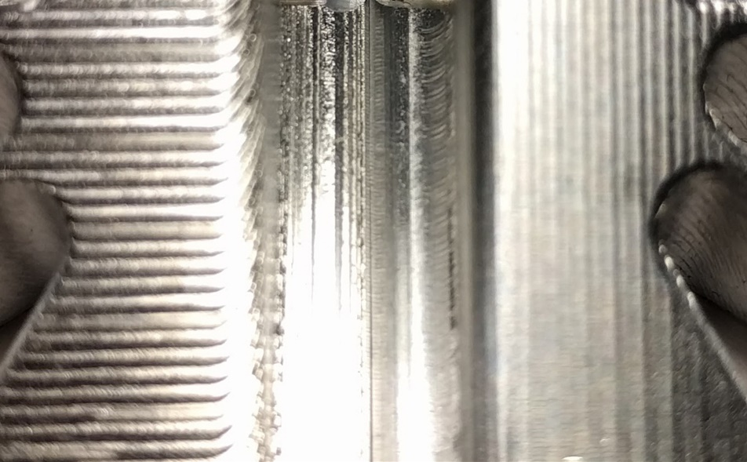

Illustration 3.2 Contrast of processing effect on slope (left: follow periphery; right:

zig-zag)

Multiple locations lead to errors. This may be the most serious problem caused by the preliminary process route. Firstly, the blank is fixed by socket screws. This kind of clamping is not as accurate as vise. Then, socket screws are replaced with 82-degree screws one by one when each slots and holes are milled and finished. Actually, during this process, the blank is not located and fixed in the same position all the time. The consequence is that between four corners and the central part, even between two corners, the blending is unnatural, or a big gap exists. Moreover, the change of position may cause tools to hit some areas where are separated by trim boundaries.

Given this, the whole route should be modified based on these two principles:

1. The less the blank is relocated, the better effect can be achieved.
2. Being grabbed by vise is more accurate than being fixed by screws.

Therefore, four corners should be processed firstly since vise can be used when milling and finishing them. It can contribute to not only better machining effects of four corners but also more accurate location for following processing work. As for worry that smaller tools may hit walls and break off when finishing four slots, I set two different kinds of trim boundaries, a big one for 1/4-inch end mill and a small one for other tools. When smaller mills are milling the slot, there will be safe clearance from walls near it.

Four slots will be processed completely. Then 82-degree screws are used to fix the blank and the central part can be milled and finished without relocation. Here it is important to set trim boundaries to keep tools away from screw caps. The difference between these two kinds of processing sequences can be seen from the comparison below:

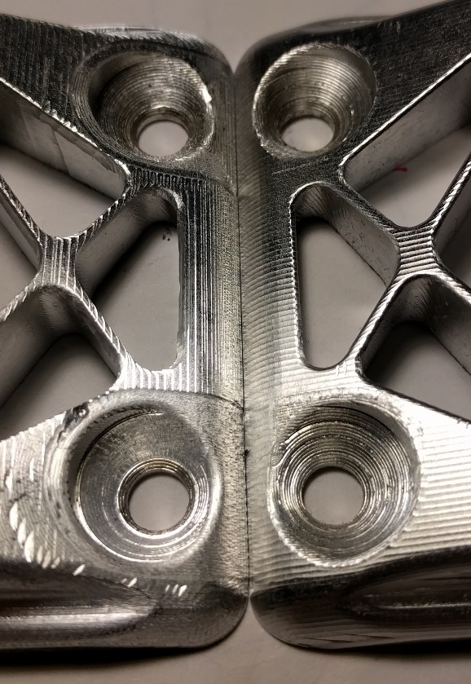

Illustration 3.3 Contrast of blending (left: central part → corners; right: corners

→ central part)

#### Datum reference and clamping

This part could be machined from one direction, so it does not need to be rotated to other positons. The whole processing work need two times of location, as previously stated, “four corners” and “central part”.

“Four corners”: choose bottom surface as reference surface, one certain point as origin. This point is an endpoint which can be selected at the bottom of the front surface on the CAD model, the projected distance from left side is 0.0455 inches (1.1557 mm).

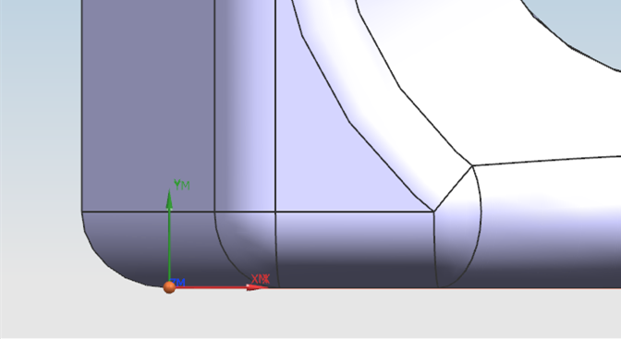

##### Drawing 3.1 Location of the origin

The blank could be grabbed by vise for four slots and holes being processed. It is worth noting that the left of blank should be exposed without covering by the jaw of vise to let tools reach and process the two slots and holes on the left.

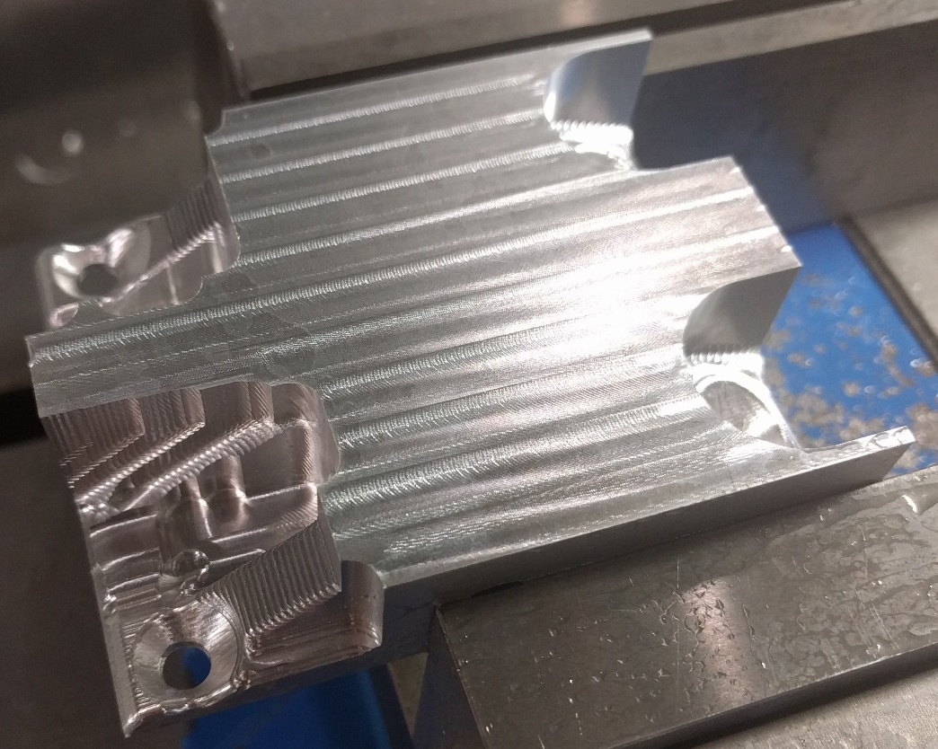

###### Illustration 3.4 Grab part of the blank to make room for processing slots

A plate is required for processing the central part. The length and width of the plate should be no longer than them of the part to avoid the top of tools when they engage deeply and cut sides of the blank.

“central part”: choose bottom surface of the plate as reference surface, the same point as origin.

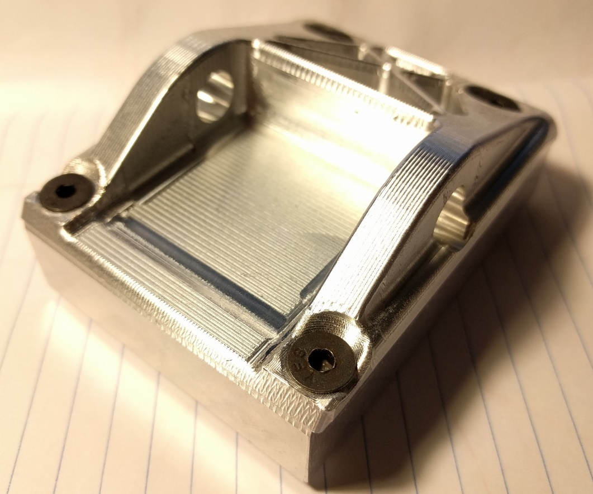

###### Illustration 3.5 Use 82-degree screws to fix blank on the plate

#### Determine machining procedure card

Complete machining procedure card has been made and, due to space limitations, showed as an appendix in the last part of this thesis. Please refer to *Appendix C: Machining procedure card of “Ski susp 02 bracket lower front A”* on page 35.

#### Future work

Here is another plan I thought out when the original plan turned out to fail.

1. Select a thick block as the blank, with a height of more than 2.5 inches, that is, 2 times of the height of one part plus 1.0 inch;
2. Grab the lower part of this block with vise and process all areas on the top;
3. Cut the processed half from the blank and process on the rest material to get the second part.

In a short time, I could not find such thick material, as a result, I had to lay this plan aside. Although this plan may cause some waste of material, better machining effect could be achieved since during the whole process, the blank will not move. If I have chance and can find suitable material, I would like to put this plan into effect.

# Refences

1. Haas Automation, Inc. USA. (2015). Pocket Guide and Reference Charts for CNC Machinists. Oxford, CA: Haas Automation, Inc. USA.
2. Peter Smid. (2003). CNC Programming Handbook, 2nd Edition. New York: Industrial Press Inc.
3. Franklin D Jones, Henry H Ryffel, Erik Oberg, Christopher J McCauley, Ricardo M Heald. (2004). Machinery's Handbook, 27th Edition (Toolbox Edition). New York: Industrial Press Inc.
4. Online Instructor. (2015). NX 10 Tutorial: Sketching, Feature Modeling, Assemblies, Drawings, Sheet Metal, and Simulation basics. CreateSpace Independent Publishing Platform.

# Appendix A: Machining procedure card of “Ss02rafA”



# Appendix B: Machining procedure card of “Ski susp 02 rocker arm rear A”



# Appendix C: Machining procedure card of “Ski susp 02 bracket lower front A”



# Vita

Longfu Hu was born in Wuhu, Anhui Province, China on November 8, 1992. Between 2010 and 2015 he studied Mechanical engineering and Japanese at Dalian University of Technology in Dalian, China. Then he entered into P.C. Rossin College of Engineering and Applied Science of Lehigh University to pursue his Master of Science degree. His research area is CAD/CAM and process design.